Creating a JavaFX Project:

Note: These instructions were complete and functional at the time the textbook was published. Please check the textbook website frequently for any updated instructions, as software and necessary steps may change unexpectedly and without announcement from the software developers / copyright holders.

https://www.prospectpressvt.com/textbooks/ezell-java

Apache NetBeans IDE:

- After NetBeans has opened, click on “File” -> “New Project”.
- In the “Categories” section in the “New Project” dialog box that opens, make sure that “Java with Maven” is selected. In the “Projects:” template section on the right, click on “Simple JavaFX Maven Archetype (Gluon)” project type.
  - If this is the first time that JavaFX has been used in NetBeans on your machine, you may see a message in the “Description:” section that reads “This feature is not yet enabled. Press Next to Activate it.”
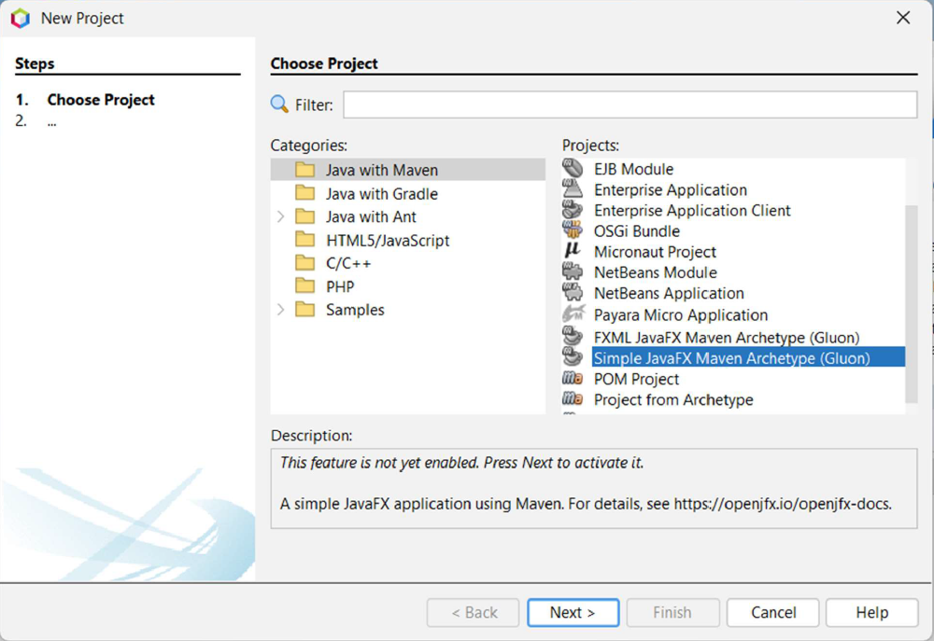
- Press the “Next >” button.
- If JavaFX has been used in NetBeans on your computer before, you will not see the “Finding Feature” screen. If this is the first time JavaFX has been used, you will.
  - On the “Finding Feature” screen, make sure that “JavaFX Implementation for Windows” has been checked and click the “Download and Activate” button.
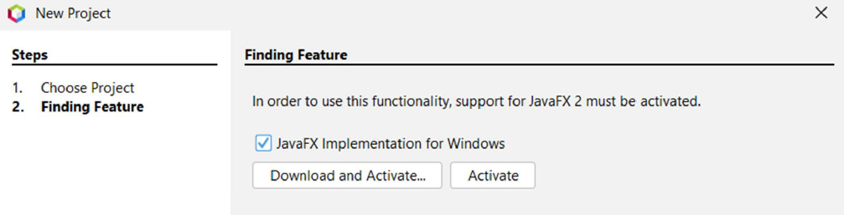
  - On the “NetBeans IDE Installer” window that appears next, click “Next >”
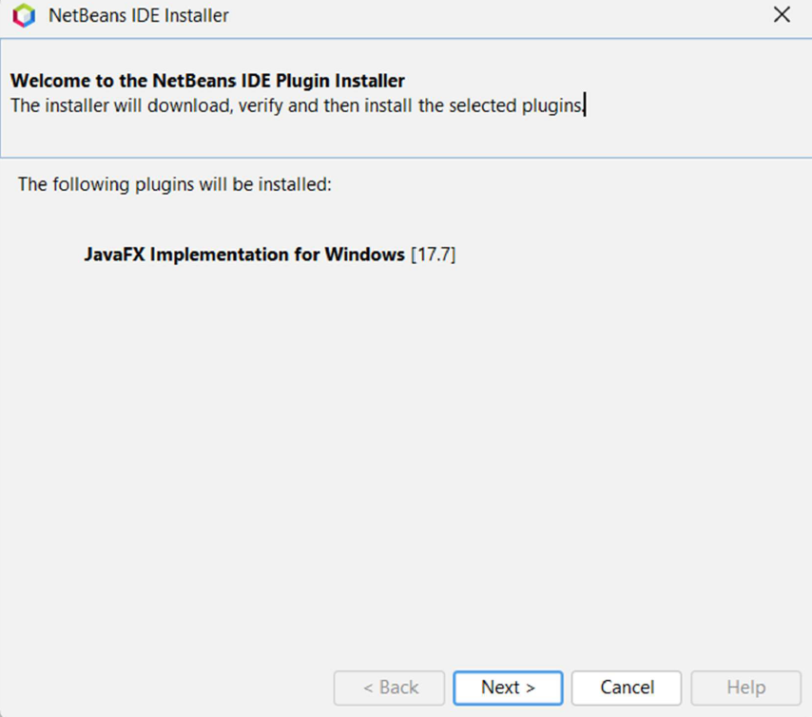

  - Read through the “License Agreement” section and after you are comfortable with the terms, ensure the “I accept the terms in all the license agreements” checkbox is checked, then click the “Install” button.
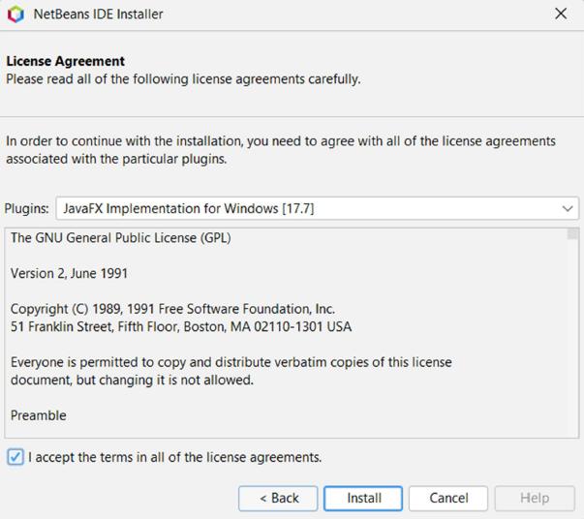

  - After JavaFX installs, you should see an “Installation completed successfully” screen. Click the “Finish” button.
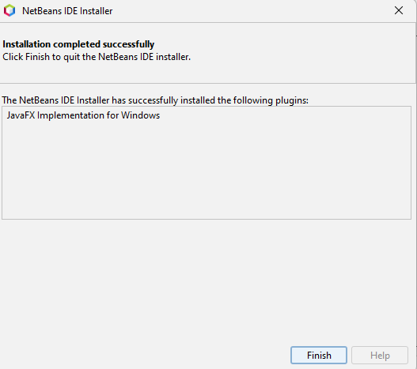

- You will return to the new project dialog box. You will see a brief prompt of “Activating JavaFX 2”.
- Once this is complete, the “Name and Location” window will appear for your new project. In the “Project Name:” text field, name your project. Ensure that you click “Browse” beside the “Project Location” box and choose a location on your computer that you are familiar with/can find later if needed. The rest of the text fields can remain with defaults unless you are given specific steps by your instructor. Click “Finish” to complete the new project creation steps.
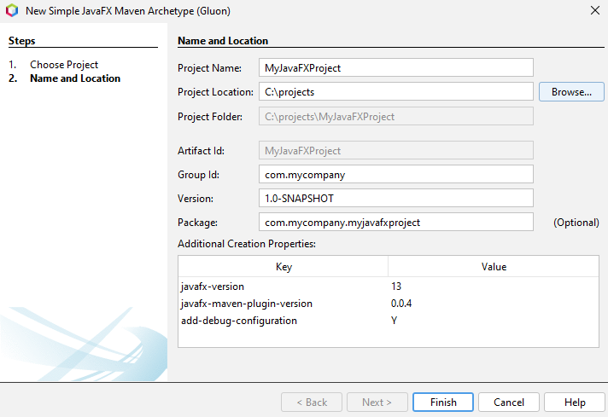

- Once the project is open, ensure that the “Projects” tab is open (“Window” -> “Projects”) and expand both the “Dependencies” section and the “Project Files” section. Note the version number of the JavaFX dependencies (Most likely “13”). Double-click and open “pom.xml” in the “Project Files” section.
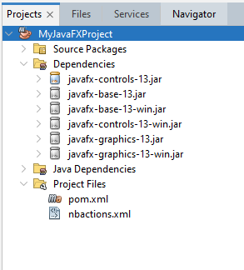

- The website https://mvnrepository.com provides a searchable database of XML that can be added to the pom.xml file to import new dependencies into your Java and JavaFX Maven-type projects. From there, a search for the latest version of “Java FX controls” yields the following version number:
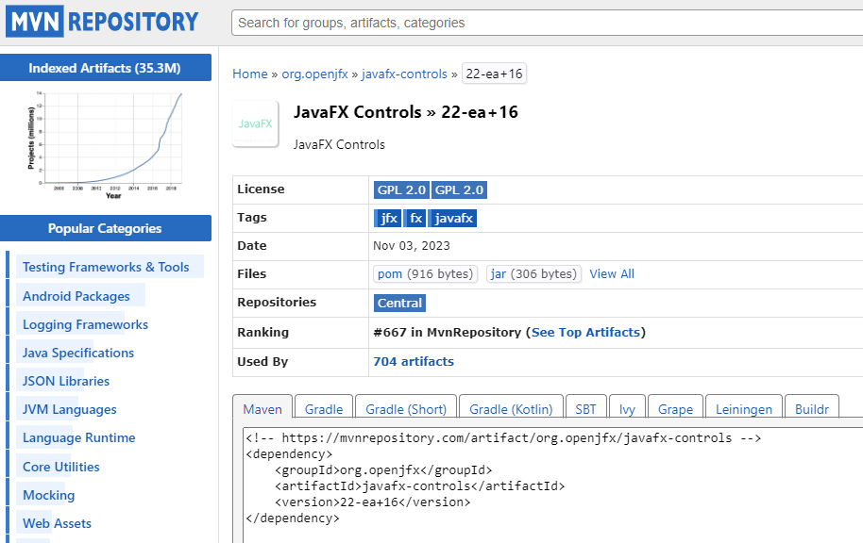
- Edit your pom.xml file in the following way:
  - Scroll down until you find the XML tag for “Dependencies”
  - Within this, find the “Dependency” section for a groupID of “org.openjfx”
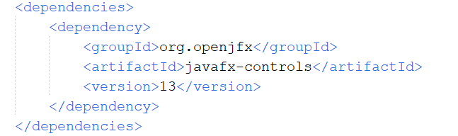
  - Change the value for the <version> tag from its current number to the latest version (at the time of publication, this was: 22-ea+16)
  - Click the “Save All” button or go to File -> Save All. This will cause your project to download the latest version of the JavaFX dependencies, updating it. Note: For Mac OS X users, this step is particularly important! Otherwise, there maybe font display issues in your JavaFX forms.
  - Close your pom.xml after you have verified that the dependencies have updated.
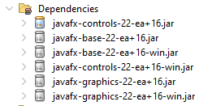
- You are now ready to start developing your JavaFX Application!

Eclipse Foundation: Eclipse IDE

- With Eclipse open, click “File” -> “New” -> “Project. . .”
- In the “New Project” wizard dialog that opens, expand the “Maven” section and click “Maven Project”, then click “Next >”.
- On the “New Maven Project” dialog, choose a workspace location by clicking the “Browse…” button or click “Use default Workspace location” (if you know where that location is at!). Click “Next >”.
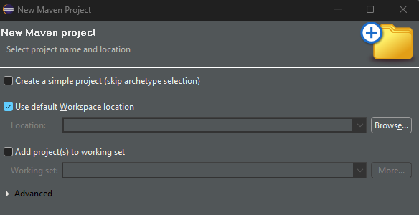
- On the “Select an Archetype” screen, if this is the first time the JavaFX archetype has been installed in Eclipse in this IDE, click the “Add Archetype…” button. Otherwise, continue on to step #5.
  - In the “Group ID:” text field, specify: org.openjfx
  - In the “Artifact ID” text field, specify: javafx-archetype-simple
  - In the “Archetype Version:” text field, specify: 0.0.6
Note: This was the latest version at the time of publication. Check https://openjfx.io/openjfx-docs/ for any updated version numbers.
  - Leave the “Repository URL:” field blank.
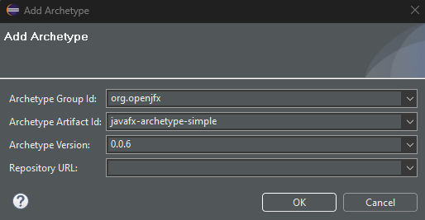

  - Click the “OK” button. This will take you back to the main “New Project” dialog.

- In the “Filter” text field, type “org.openjfx” or simply scroll down until you see that option. Click and highlight that option then click “Next >”.
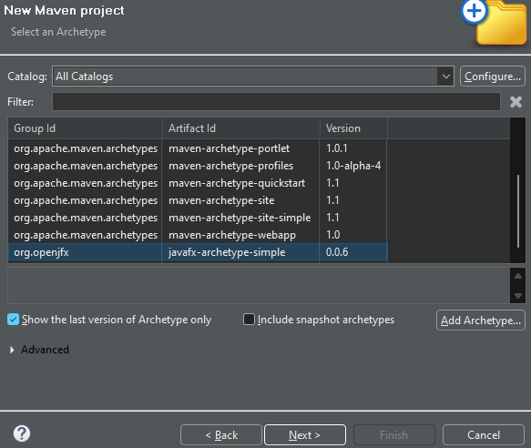

- In the last “New Maven Project” dialog box, type:
  - For “Group ID:” com.mycompany (or as given to you by your Instructor)
  - For “Artifact ID:” …the name you wish to give your JavaFX Project.
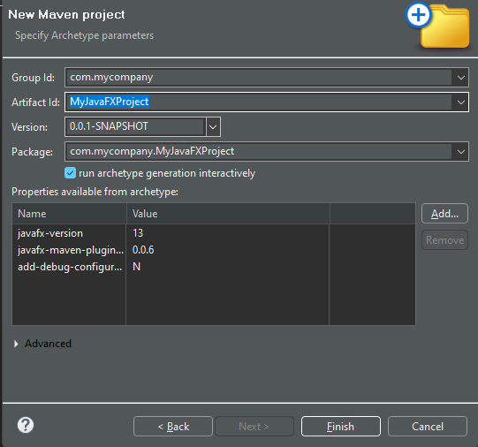
- Click the “Finish” button.
- The project will begin downloading necessary JavaFX files. In the “Console” in Eclipse, you may see this prompt:
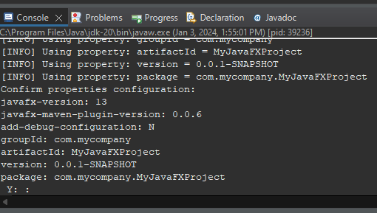
Place your cursor to the right of the “Y: :” and hit the Enter key to have the project continue to build and configure.
- Once finished, your project will appear in the “Project Explorer” window (Window -> Show View -> Project Explorer). Expand the “Maven Dependencies” section. Also, note that at the bottom of the Project Explorer listing, you will see a file “pom.xml”. Open this file.
- The website https://mvnrepository.com provides a searchable database of XML that can be added to the pom.xml file to import new dependencies into your Java and JavaFX Maven-type projects. From there, a search for the latest version of “Java FX controls” yields the following version number:
- In pom.xml, you will want to change the version number of the javafx-controls dependency.
  - Scroll down until you find the XML tag for “Dependencies”
  - Within this, find the “Dependency” section for a groupID of “org.openjfx”
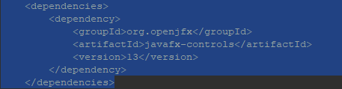
  - Change the value for the <version> tag from its current number to the latest version (at the time of publication, this was: 22-ea+16)
  - Click the “Save All” button or go to File -> Save All. This will cause your project to download the latest version of the JavaFX dependencies, updating it. Note: For Mac OS X users, this step is particularly important! Otherwise, there maybe font display issues in your JavaFX forms.
  - Close your pom.xml after you have verified that the dependencies have updated.
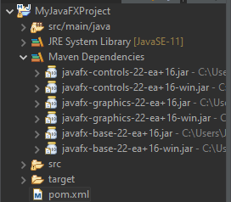

- In the “Project Explorer”, expand the src folder, then the package folder, and click App.java once. Then click the dropdown by the “Run” button at the top and click the “1 App” to run App.java as a Java application.
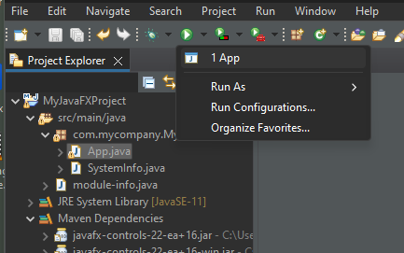

- A JavaFX GUI window should appear and you should see the latest version of JavaFX listed in the example code for the project!
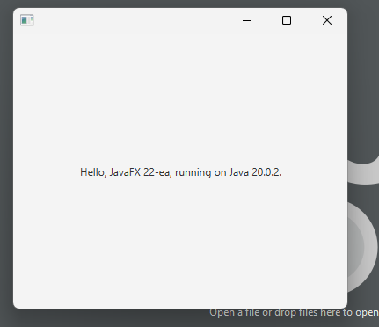

Oracle®, Java, MySQL, and NetSuite are registered trademarks of Oracle and/or its affiliates. Other names may be trademarks of their respective owners.
NetBeans IDE and NetBeans Platform are based on Apache NetBeans from The Apache Software Foundation and are licensed under Apache License Version 2.0. For more information, please visit https://netbeans.apache.org/. Copyright 2017 – 2024 The Apache Software Foundation. Apache, Apache NetBeans, the Apache feather logo and the Apache NetBeans logo are trademarks of The Apache Software Foundation.
Eclipse® and the Eclipse logo are trademarks of Eclipse Foundation, Inc. © Copyright Eclipse Contributors and others 2000, 2024. The Eclipse project includes software developed by other open-source projects including the Apache Software Foundation, https://www.apache.org/.

